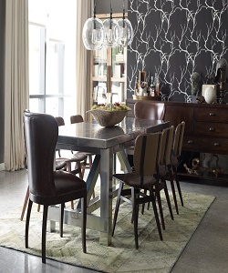

Dining table

$127.45

Availability: In stock

Description

High Wingback Dining Room Chairs with brown Modern Inch Table. Luxuriously quilted top-grain leather is accented by a pop of heavy burlap, both adding a tactile contrast and nodding to the old tradition of hessian-backed chairs. Available in ebony or tobacco-brown leather upholstery.